

|  |
| --- |
| CS7CS3 - Advanced Software Engineering – Group 5  Technical Specification Document  SUSTAINABLE CITY MANAGEMENT |

**DOCUMENT VERSION 0.1**

**30.01.2019**

**AUTHORS**

|  |  |  |
| --- | --- | --- |
| **Name** | **Role** | **Department** |
| Roman Shaikh |  |  |
| Lal Singh |  |  |

**DOCUMENT HISTORY**

|  |  |  |  |
| --- | --- | --- | --- |
| **Date** | **Version** | **Document Revision Description** | **Document Author** |
| 04/02/2019 | 0.1 | Initial release | Roman Shaikh |
|  |  |  |  |
|  |  |  |  |
|  |  |  |  |
|  |  |  |  |

**APPROVALS**

|  |  |  |  |
| --- | --- | --- | --- |
| **Approval Date** | **Approved Version** | **Approver Role** | **Approver** |
|  |  |  |  |
|  |  |  |  |
|  |  |  |  |
|  |  |  |  |

**Table of Contents**

1. Introduction 3

1.1 Purpose of the document 3

1.4 Related documents 3

1.5 Terms/Acronyms and Definitions 3

1.6 Risks and Assumptions 4

2. System/ Solution Overview 4

2.1 Architecture Diagram 4

2.2 System requirements 6

2.3 Dependencies and Change Impacts 6

3. Fault tolerance 6

6. References 6

7. Open Issues 6

Appendix 6

# Introduction

The goal of this project is to provide a decision-support tool for city managers and city service providers to optimize mobility service delivery. A dashboard will be implemented that provides information to mobility service providers as to the current volume of usage, the emissions impact of current travel patterns, and potential areas of over- or under-use.

## Purpose of the document

This Technical Specification Document will provide detailed information on *how* the system solution will implement the requested behavior. This document is created based on the high-level requirements identified in the Business Requirements Document. It contains the details of system architecture, system requirements and the external technologies that will be used.

## 1.4 Related documents

|  |  |  |
| --- | --- | --- |
| **Component** | **Name (with link to the document)** | **Description** |
|  |  |  |

## 1.5 Terms/Acronyms and Definitions

|  |  |  |
| --- | --- | --- |
| **Term/Acronym** | **Definition** | **Description** |
|  |  |  |

## 1.6 Risks and Assumptions

This document assumes that the

# System/ Solution Overview

The system will be designed using the three-layered architecture namely Data Layer, Business processing logic Layer and Presentation layer. Each of this layer will support different aspects of the Business requirement.

## Architecture Diagram

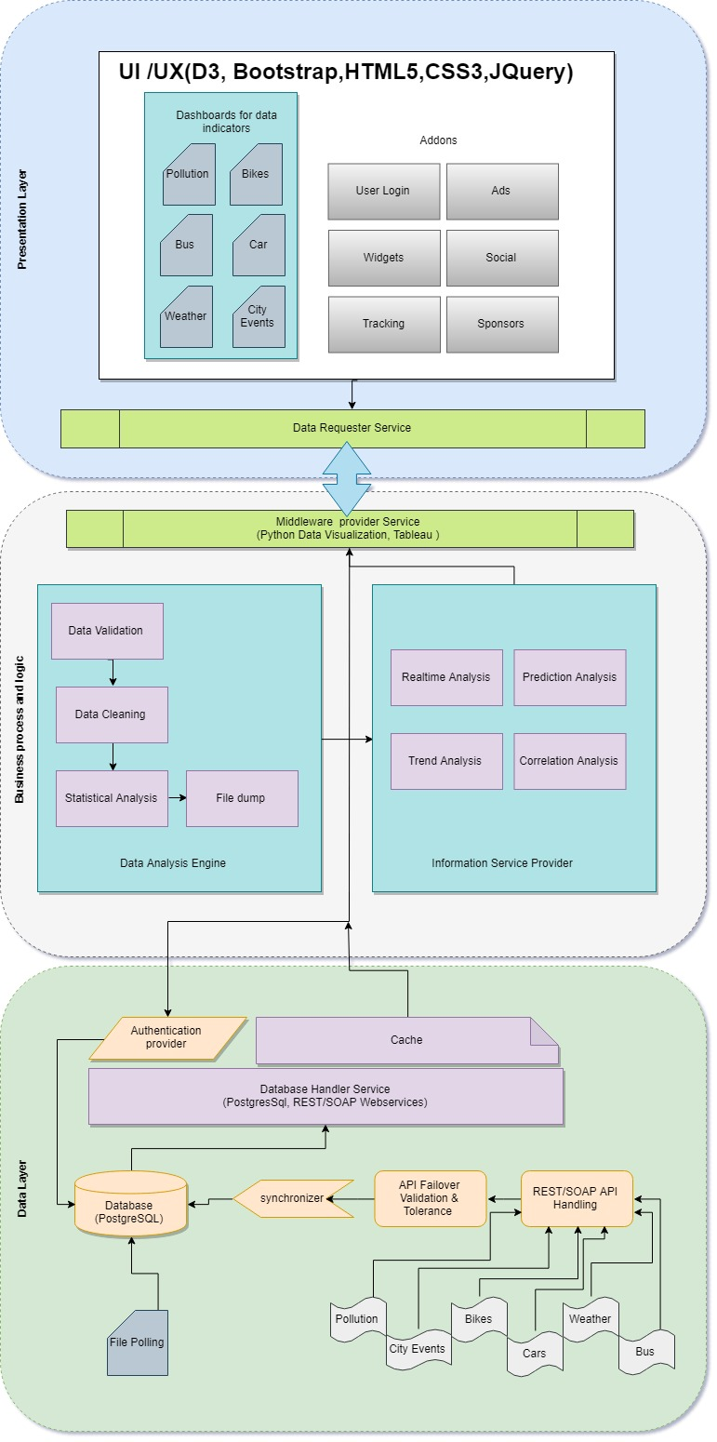

## System requirements

Following describes the minimum system requirements for the system to be functional for required number of audiences.

* OS: Linux – Ubuntu 18.04
* Memory: 16 GB DDR5
* Storage: 1TB NAS with RAID 1 Mirroring
* Database: PostgreSQL v-11.1
* Technologies: Python, Django framework, D3, Tableau
* Webserver: Apache / NGIX

# Fault tolerance

# References

# Open Issues

|  |  |  |  |  |  |  |  |
| --- | --- | --- | --- | --- | --- | --- | --- |
| **Issue ID** | **Issue** | **Raised By** | **Raised On** | **Solution/ Decision** | **Resolved By** | **Resolved On** | **Status** |
|  |  |  |  |  |  |  |  |

# Appendix